**Part-B**

**1. Ask the user to enter their name using a prompt:**

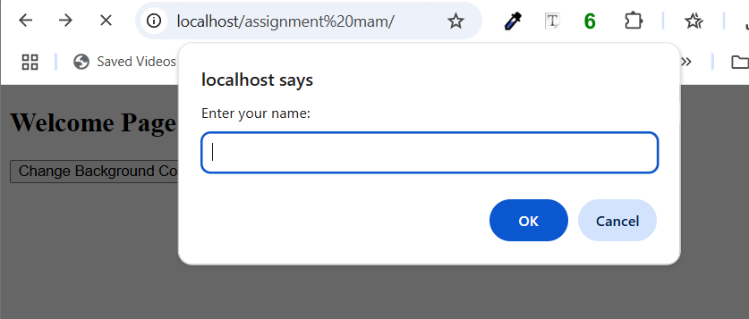

**2. Display a personalized greeting using alert() (e.g., "Hello, [name]!"):**

**3. Show the greeting in a specific <div> on the web page:**

**4. Add a button that, when clicked, changes the background color of the page randomly:**

**Part-C**

**1. Create a form with fields: Name, Email, and Submit button:**

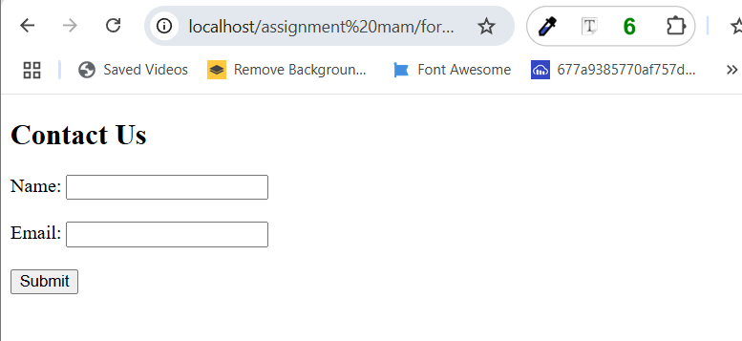

**2. Use POST method to send data to a PHP file:**

**3. The PHP file should:**

**o Validate if name and email are not empty.**

**o Display: Thank you, [Name]. We have received your email: [Email].**

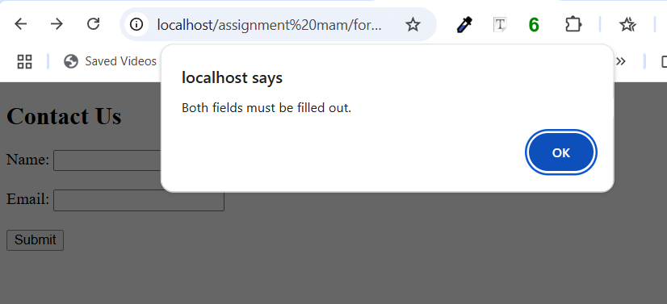

**Github live link for part-B,C:**

<https://habiba22akter.github.io/assignment-mam-39-/>